Supplemental Materials—Chapter 3

— a Unit on the 2010 BP Deepwater Horizon Macondo Blowout Oil Spill

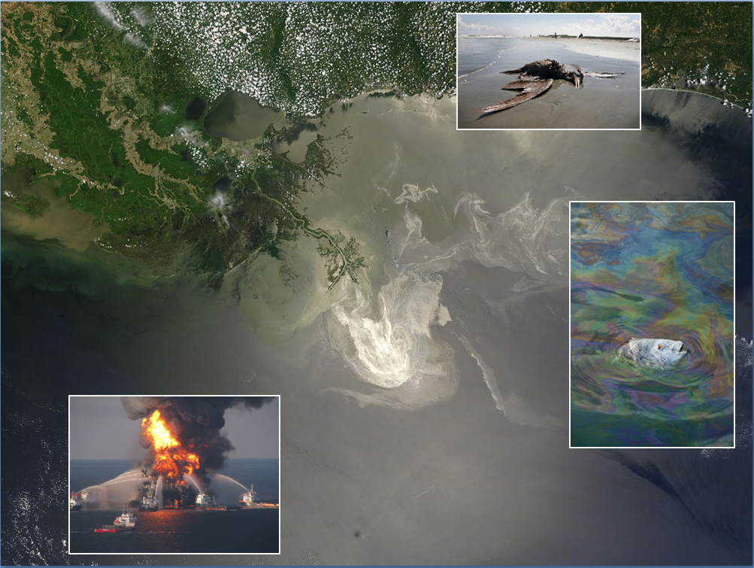
Assignment
Available on the coursebook website:
•Read “A Timeline of the BP Deepwater Horizon Blowout Spill,” (adapted from Peter Lehner, In Deep Water: The Anatomy of a Disaster, the Fate of the Gulf & How To End Our Oil Addiction (2010).
•Read “Learning from Disasters,” ELI, comparing lessons learned from Exxon Valdez spill in 1989 and BP Macondo spill, 2010
•Skim the table of Contents of “Deep Water,“ the Final Report of the National Commission on the BP Deepwater Horizon Oil Spill and Offshore Drilling; read one section to get a sense of the Commission’s verdict on the industry and agency behavior before, during, and after the Deepwater Horizon explosion.
Also:
•Review the significant graphic and story by David Hammer, “Five Key Human Errors, Colossal Mechanical Failure Led To Fatal Gulf Oil Rig Blowout,” New Orleans Times-Picayune, Sunday, September 05, 2010
http://www.nola.com/news/gulf-oil-spill/index.ssf/2010/09/5_key_human_errors_colossal_me.html

_______________________________________________________________________

The BP Deepwater Horizon blowout precipitated a potentially game-changing milestone in national energy policy, as the decreasing volumes of oil in currently exploited fields has led to strenuous efforts to open new sources of hydrocarbons in areas once thought too risky and technologically challenging to be practical.

The BP Macondo well commenced at almost a mile below the Gulf’s surface, out of ca. 4000 wells in the Gulf it was one of less than a half dozen at that depth, drilling from the unstable sea floor 18,000 feet further down to hit a high-pressure gas and oil pool. The oil and methane hydrocarbons were doubly risky in a geological setting of brittle and highly fractured strata as well as great depth.

In retrospect it is becoming clearer that this well should not have been permitted by MMS, the federal Mineral Management Service, now BOEMRE, the Bureau of Ocean Energy Management, Regulation and Enforcement.

Deep Water, the Final Report of the National Commission is a goldmine of data on BP Deepwater, and the Commission’s website has a rich collection of graphics and supplemental reports: www.oilspillcommission.gov

COMMENTARY & QUESTIONS
Here is a basic controversy:
—Was the BP Deepwater Horizon blowout spill just a combination of unfortunate incidents that just happened to occur in sequence in an admittedly risky business to bring down the rig?
—Was it the result of a particularly negligent operator (BP having a particularly poor reputation in the industry)?
—Or was it the result of systemic deficiencies, industry and regulatory agencies operating in ultra-high risk settings with a dominant culture that put safety behind profit, characterized by complacency, collusion, and neglect, as the Exxon Valdez Commission had found 20 years before?

We tend to the systemic explanation, as the article in the readings indicates. BP’s review unsurprisingly reached a conclusion that the calamity was caused by an unfortunate concatenation of events and non-BP causes: Casselman & Swartz, The Gulf Oil Spill: BP Report Pins Most of Blame on Others — Company's Probe Cites Eight Key Errors That Led to Explosion; Contractors Transocean, Halliburton Reject the Findings, Wall Street Journal, September 9, 2010 at A4. A number of analysts, including the Wall Street Journal which produced some excellent reporting on the spill, have argued the first proposition. See the WSJ series “Deep Trouble,” running from late August into October 2010.

Which way does the Hammer article in the reading assignment incline?

